PORTFOLIO PROJECT

Submitted by

### LOKESHWARAN M Reg. No: 1P23CS017

In partial fulfilment of the requirement for the award of the Degree of

### School of computer studies (PG)

### Bharathiar University Coimbatore.

Under the Internal Supervision of

# Dr.P.V.Ravidranath,M.Sc.CS,Ph.D,

**Assistant Professor**

**School of Computer Studies-(PG)**



### Master of Science in Computer Science ,

**Rathnavel Subramaniam College of Arts and Science (Autonomous),**

### Sulur, Coimbatore – 641 402

**OCTOBER 2023**

### RATHNAVEL SUBRAMANIAM COLLEGE OF ARTS AND SCIENCE (AUTONOMOUS)

**AFFILIATED TO BHARATHIAR UNIVERSITY**

**NAAC Re-accredited & ISO 9000:2008 Certified SULUR, COIMBATORE-641402.**



**OCTOBER 2023**

**Register Number – 1P23CS017**

Certified bona fide original record of work done by **LOKESHWARAN M**

### Internal Supervisor HOD

Submitted for the project Evaluation and Viva voice held on**………………….**

### Internal Examiner External Examiner

PORTFOLIO PROJECT

# Chapter 1: 5

Video Introduction

1.1Youtube video

# Chapter 2: 6

Website bio score

2.1.Minimum 50 words(Include photo)

2.2.Download CV(resume)

# Chapter 3: 11

Contact information

3.1.Contact Information (Name , Email, Address..)

# Chapter 4: 15

Pages & Navigation

4.1.Landing Page

4.2.Navigation Bar

# Chapter 5: 25

My Skills Details

5.1.Skill Details

# Chapter 6: 30

Style Score

* 1. Style

6.2 Style links

# Chapter 7: 31

Website include the following information

7.1.Project page

7.2.Project link to Githup

# Chapter 8: 37

8.1.Project readme(Discribtion,steps to run future movement)

8.2.Githup File Structure

# 

# PORTFOLIO PROJECT

# Chapter-1

# video introduction

* 1. Youtube video introduction

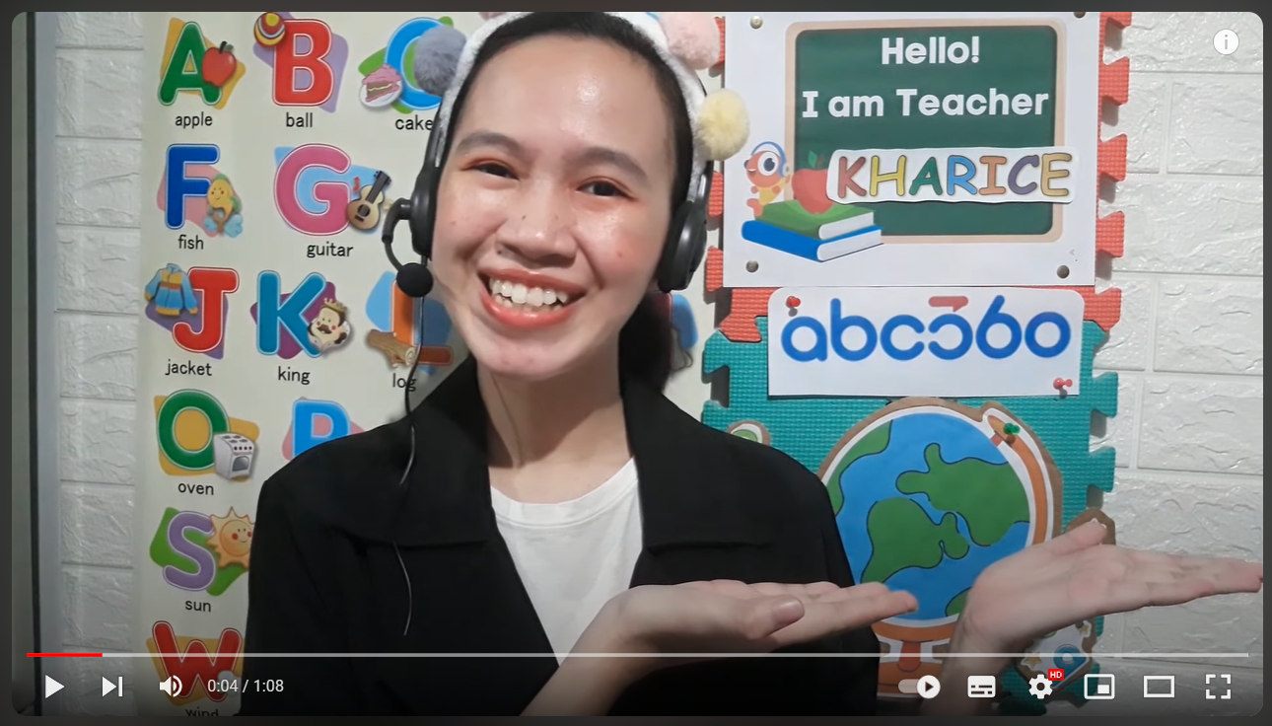

video link:

<https://youtu.be/j1eO9UOi-sc?si=R5KZJpIkiRi-yGqz>

Source code:

HTML:



# 

# Chapter-2

# Website bio Score

2.1.About me

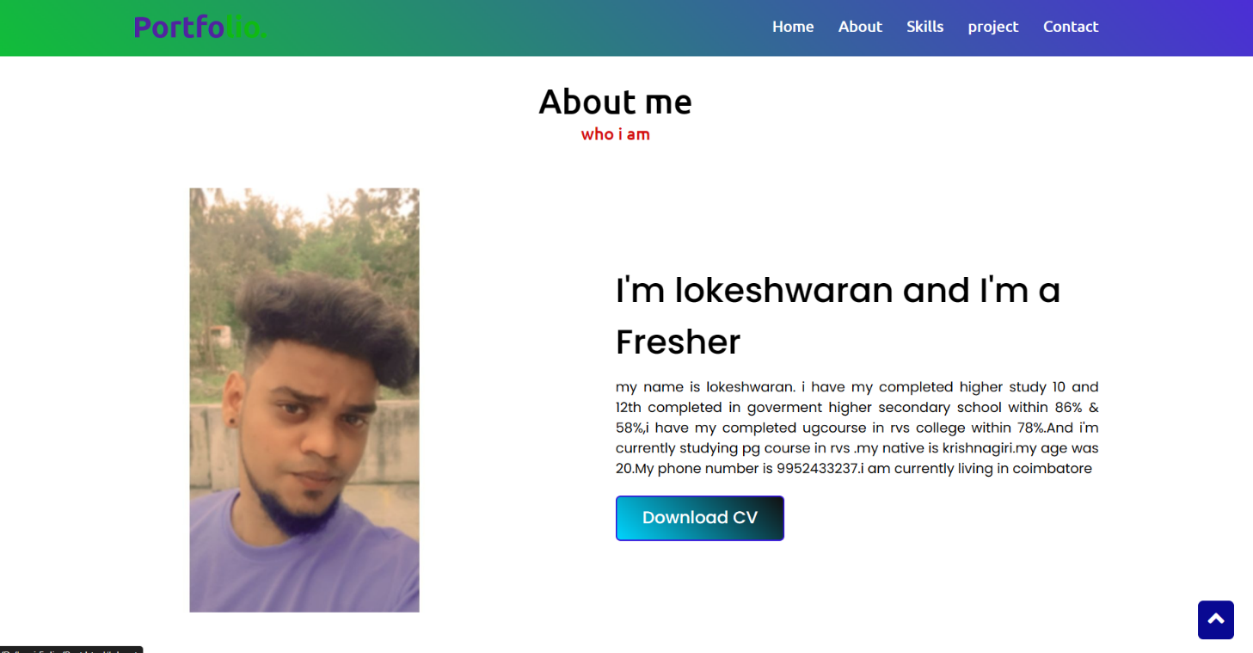

Figure-2.1.1

Discription:

In this page, there is an Image of mine, paragraph about me and also an option

called DOWNLOAD RESUME. So, that if any user wants to see the resume

they can directly download from here.

Source code:

HTML:

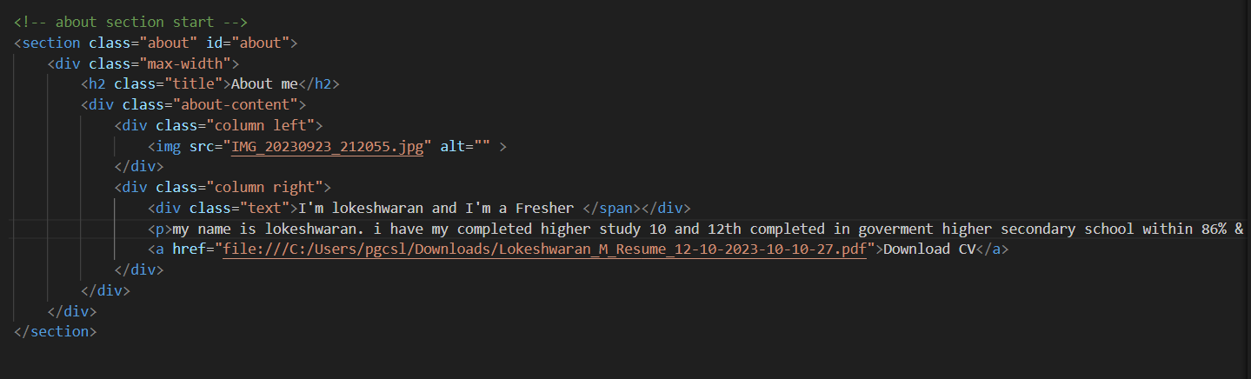

CSS:

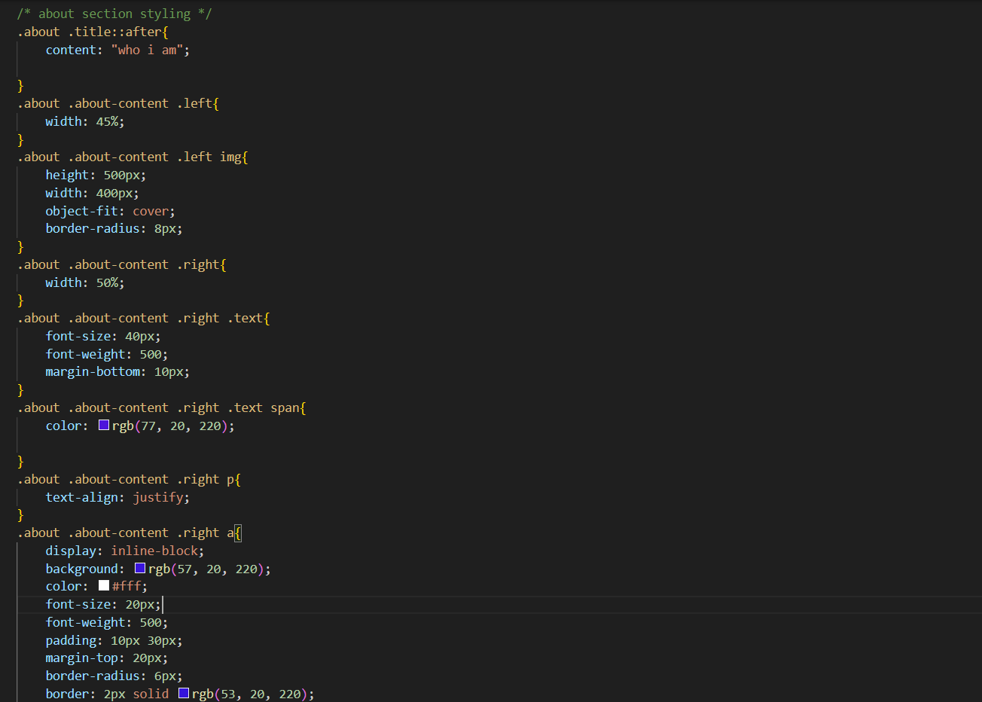

# 

2.2 Download Resume:

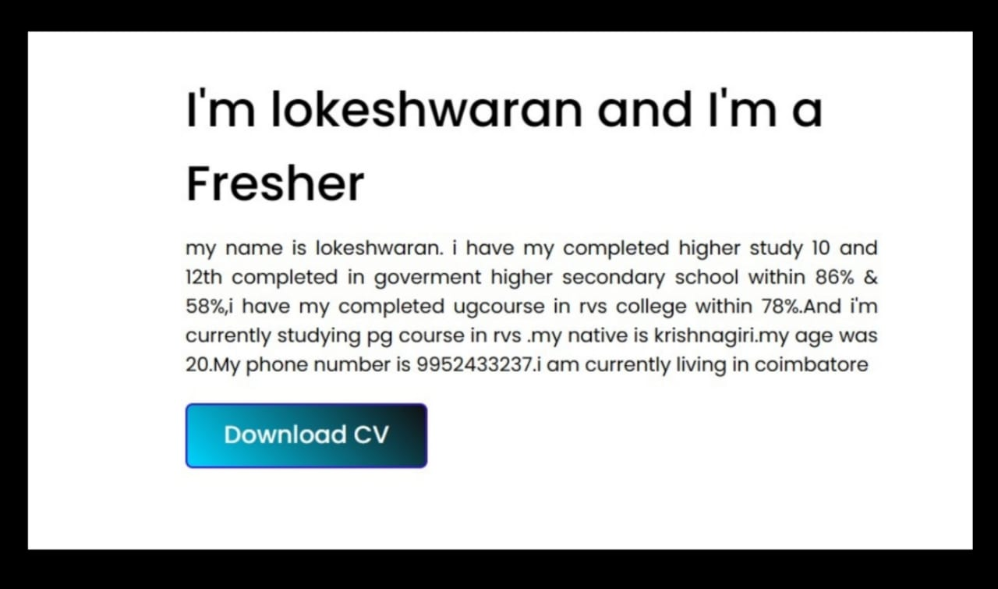

Figure2.2.1

Source code:

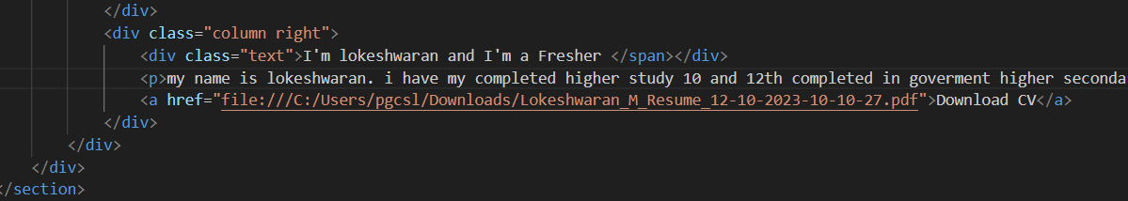

Download Resume:

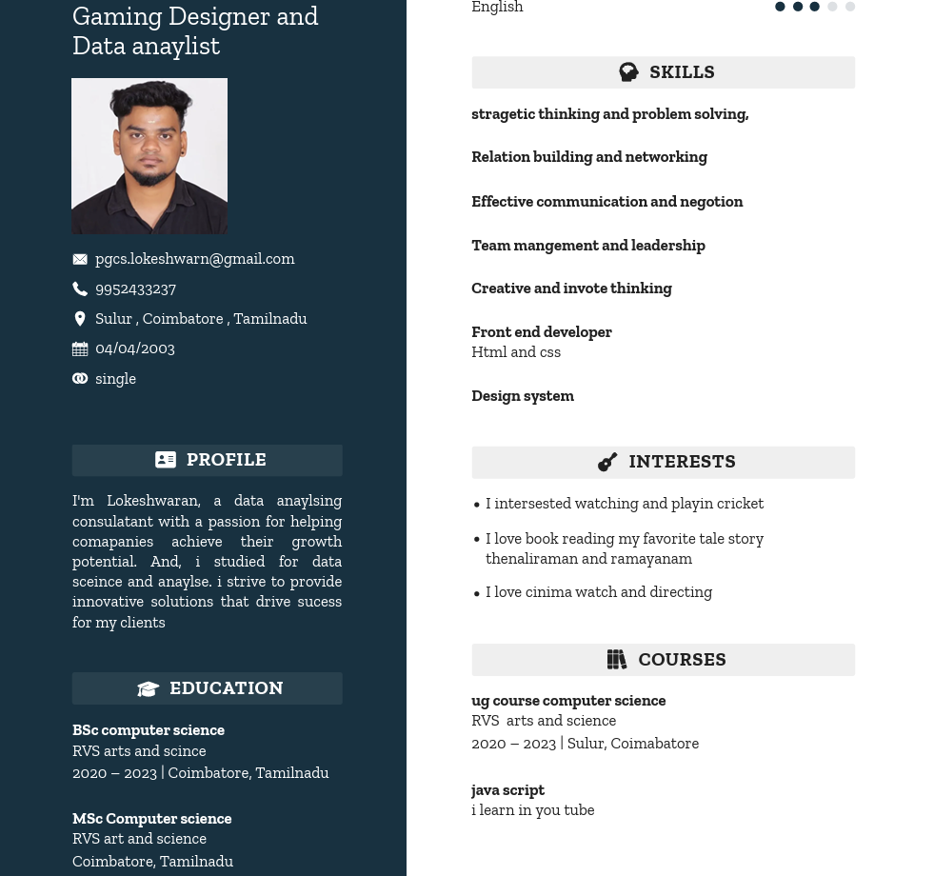

Figure-2.2.2

Chapter-3

contact information

3.1 Contact page:

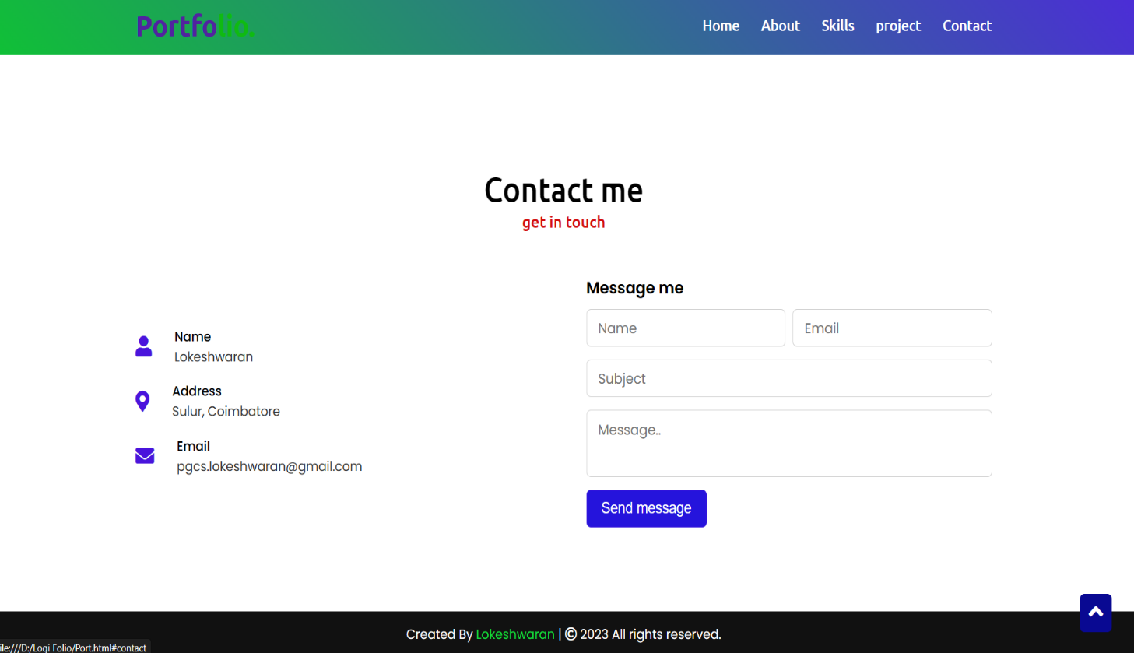

Figure-3.1.1

Discription:

The above displayed figure is a contact pagenin the website,

if the user wants to contactme,they can fill the form with

their validate details.Once the user filled and submitted the

form the page will be display figure-2.1.this will be

possible only filled the all field in the form.

HTML:

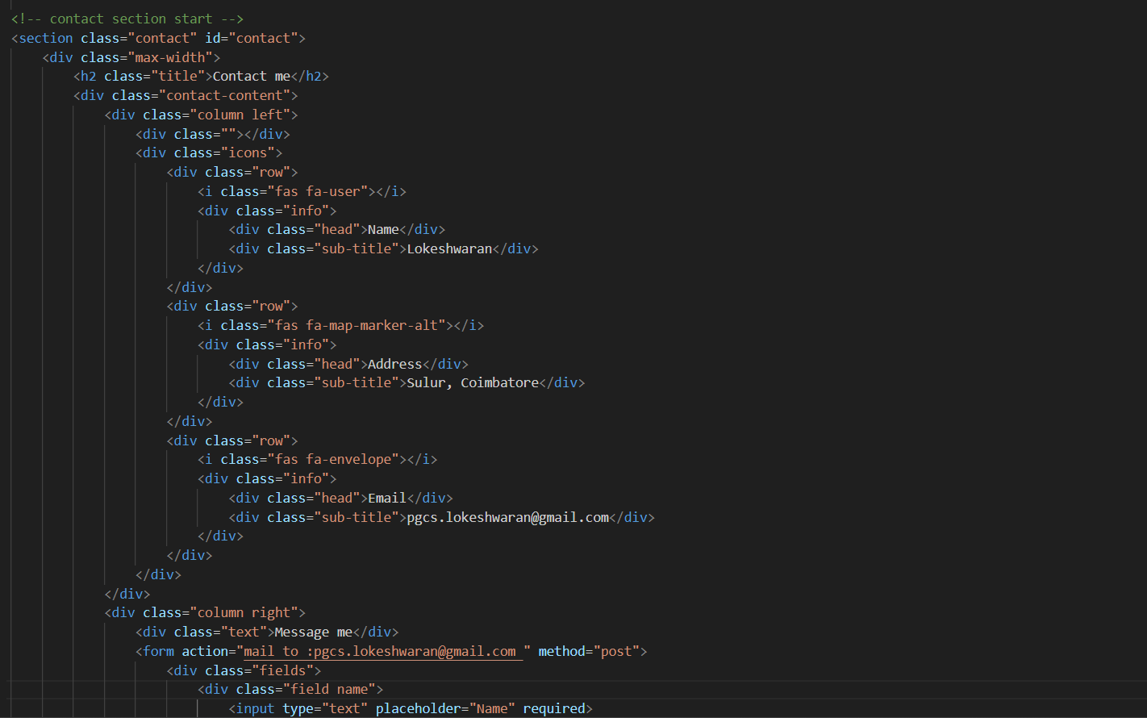

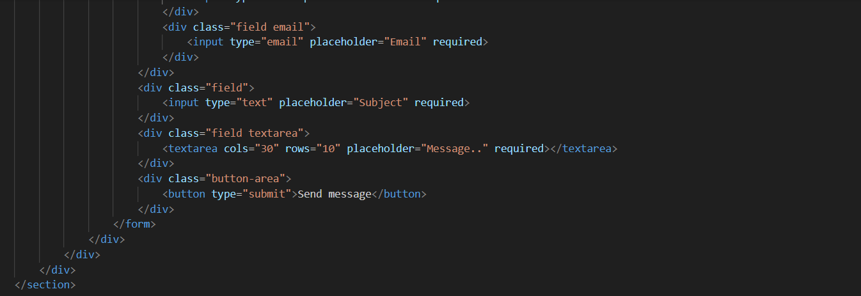

**CSS:**

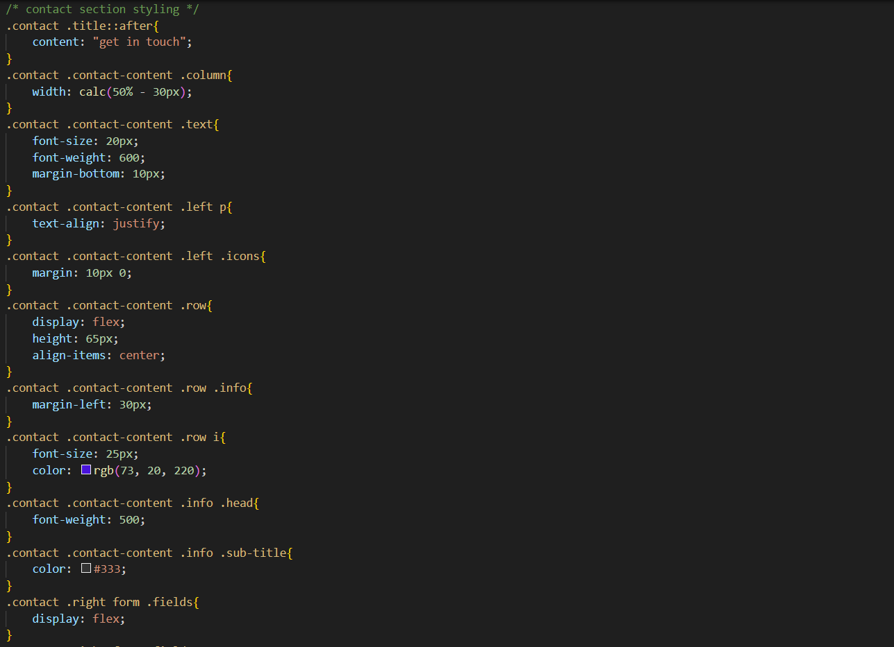

# 

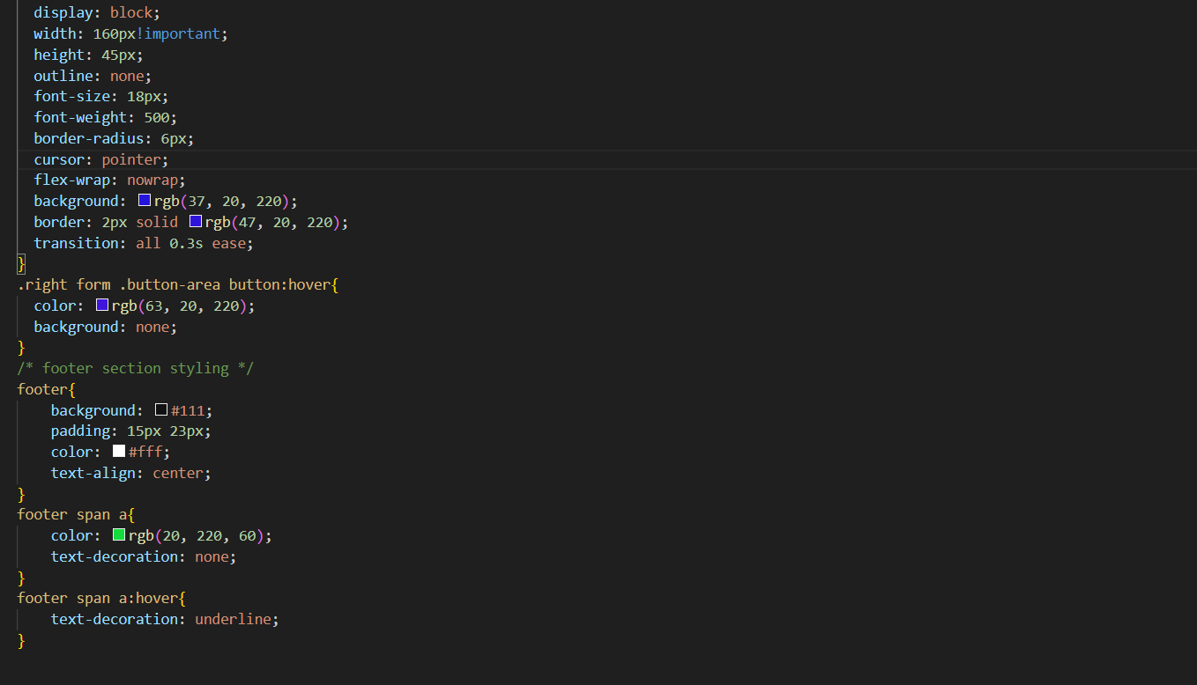

# CHAPTER-4

# 

# Pages and navigation

4.1 landing page:

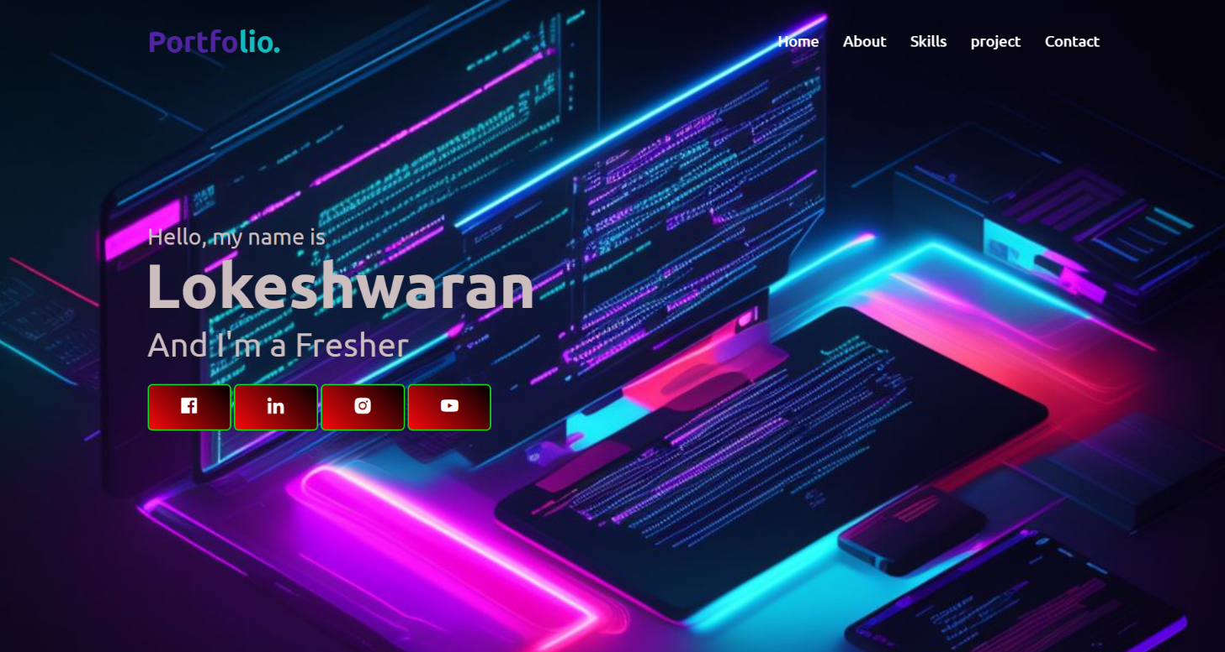

Figure-4.1.1

Discription:

The above figures 3.1.1 are the screenshot of Homepage

in a desktop view. And, this is a home screen of the

portfolio which shows the landing page and navigation

bar.

Which shown as Figure 4.1.1

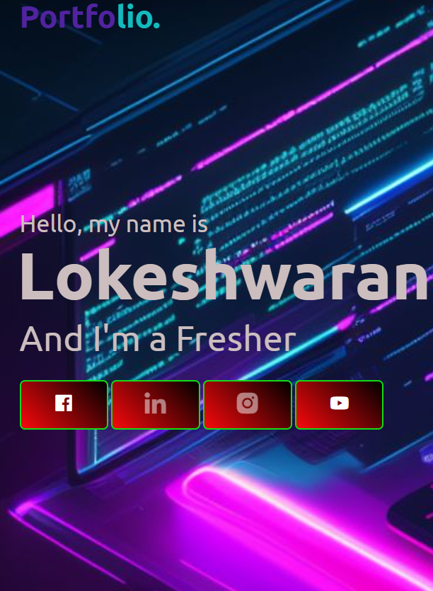

Figure 4.1.2

Discription:

The above figure 4.1.2 are the screenshot of home page

In mobile view. And, this is home of the screen of the

Portfolio. Which shows the landing page and Navigation

Bar.which shown as figure 4.1.2.

Source code:

HTML:

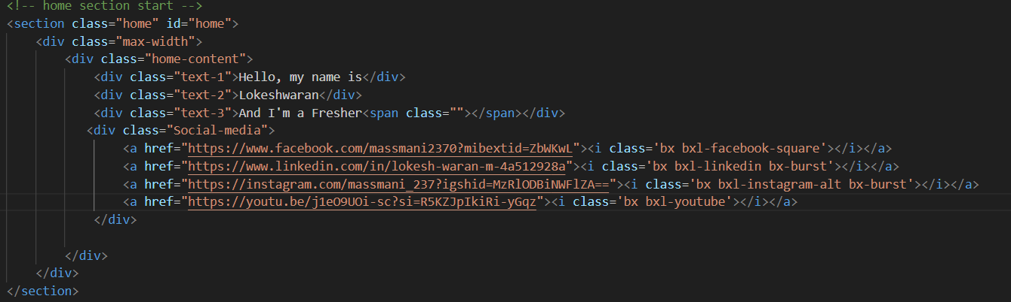

CSS:

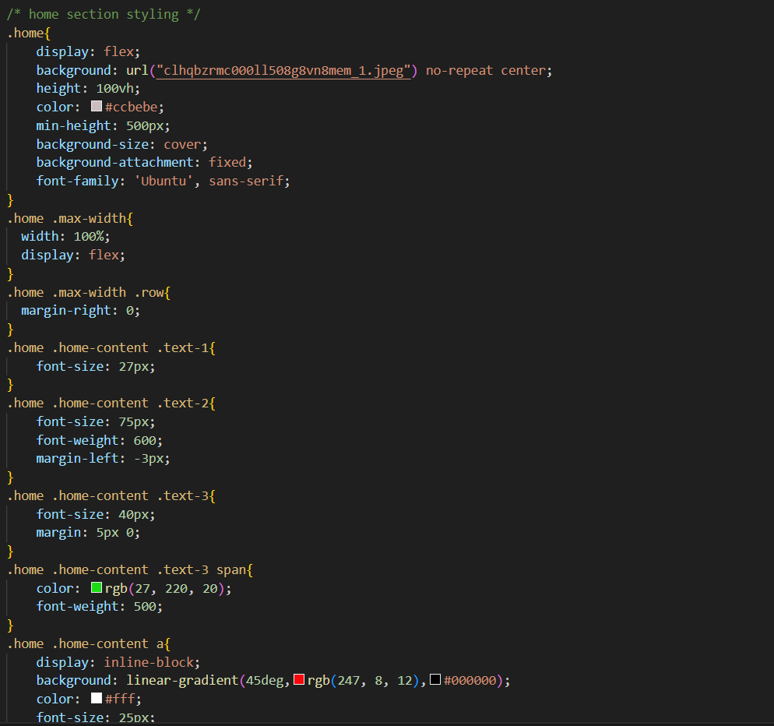

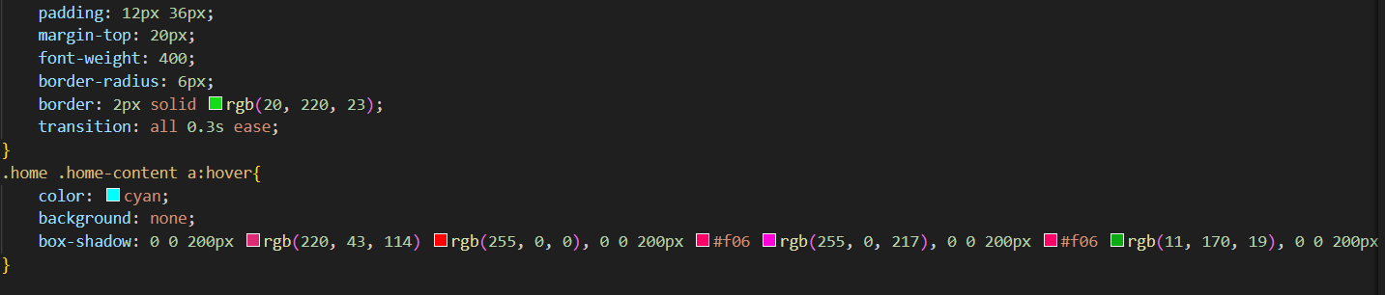

JAVASCRIPT:

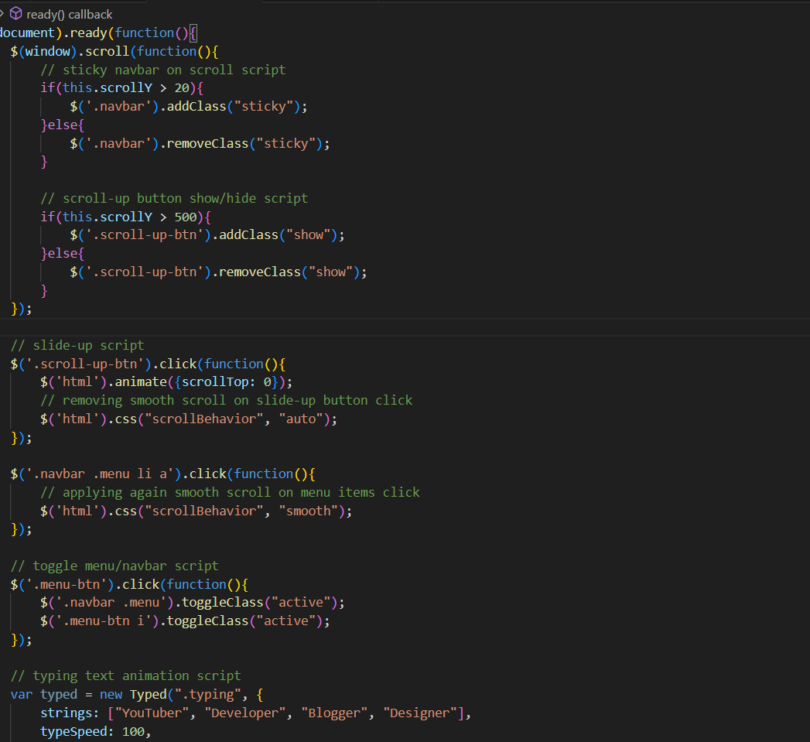

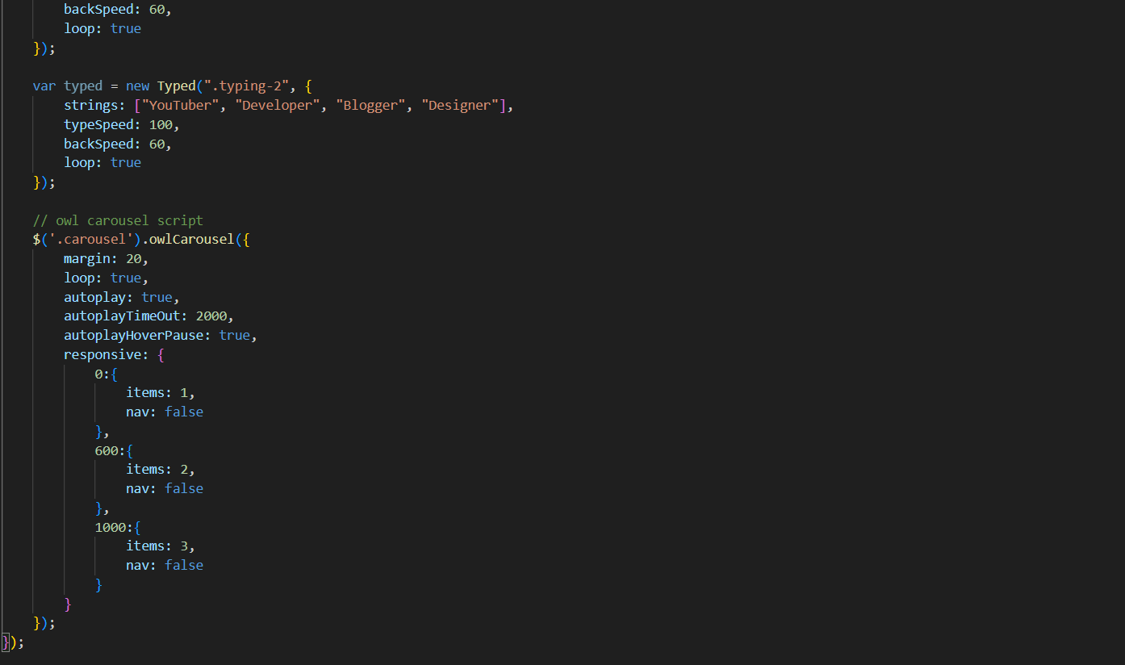

4.2 Navigation Bar



Figure 4.2.1

Discription:

The figure 3.2.1 are the samples of navigation bar both

Desktopview. This was a user friendly method only, so the

User can easily use the features

Mobile view toggle:

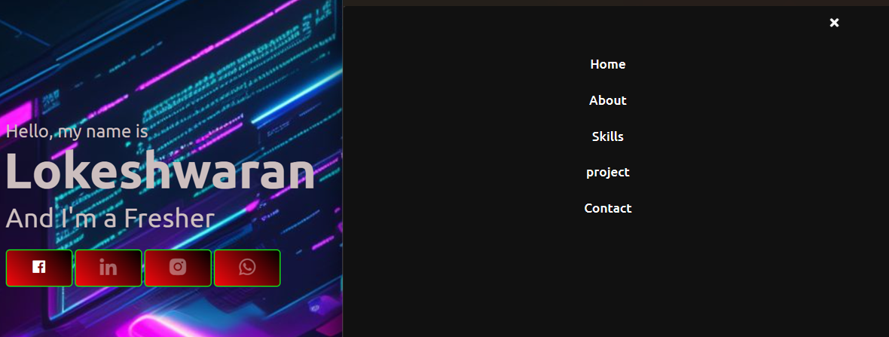

Figure 4.2.2

Discription:

The figure 3.2.2 are the samples of navigation bar in

Both mobile view .

This was friendly method only. So other can easily

user the features.

Features:

There are many styles are added . whenever the user

move lists to the navigation it will change the color

to goldenrod. And also the navigation bar will best

table in the same option ,even we switch to any other

pages.

Sourcecode

HTML:

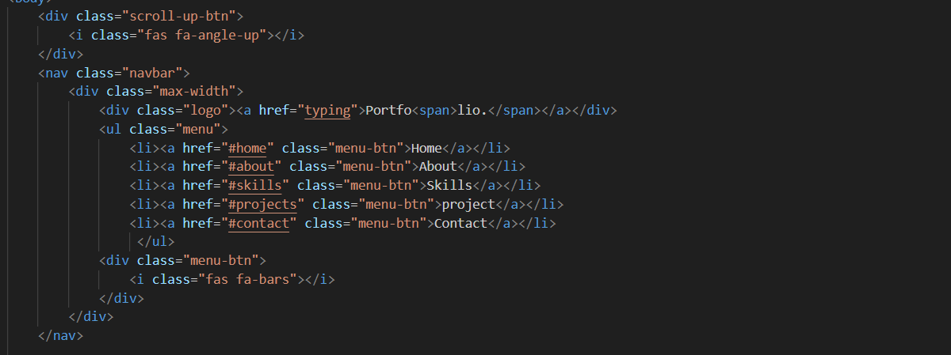

CSS:

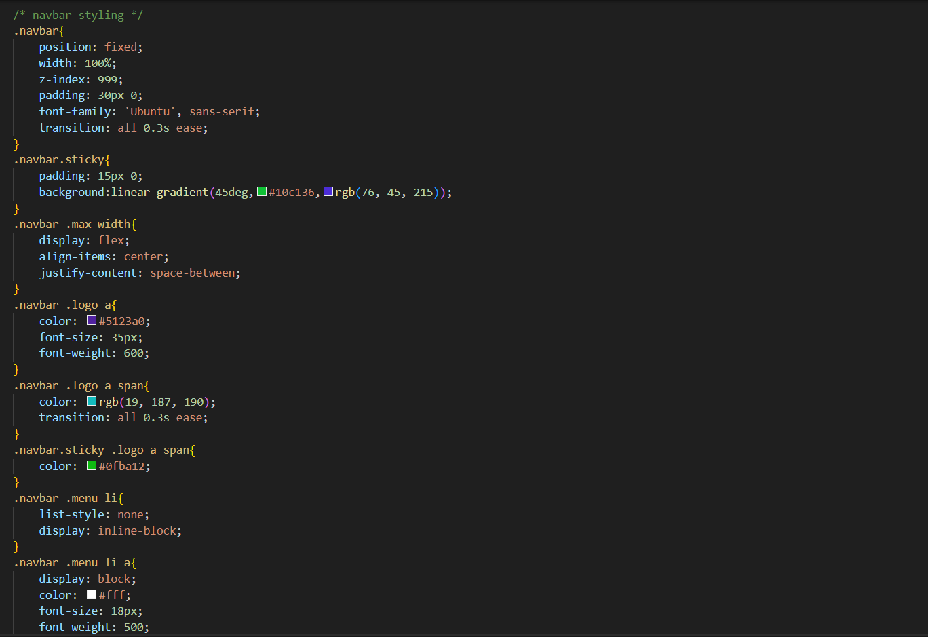

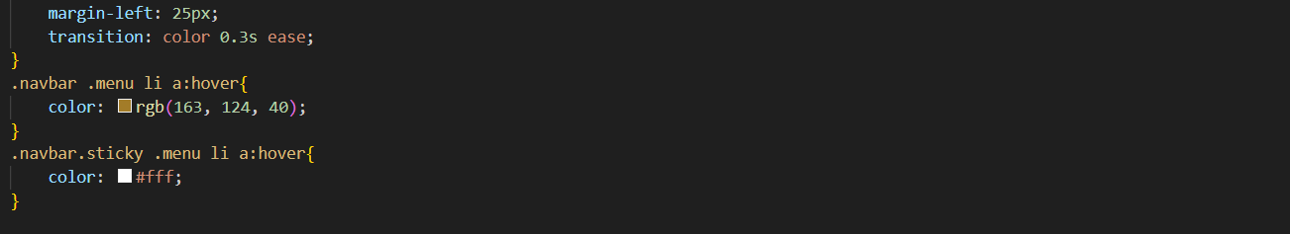

Chapter-5

My skills details

5.1 Skill page

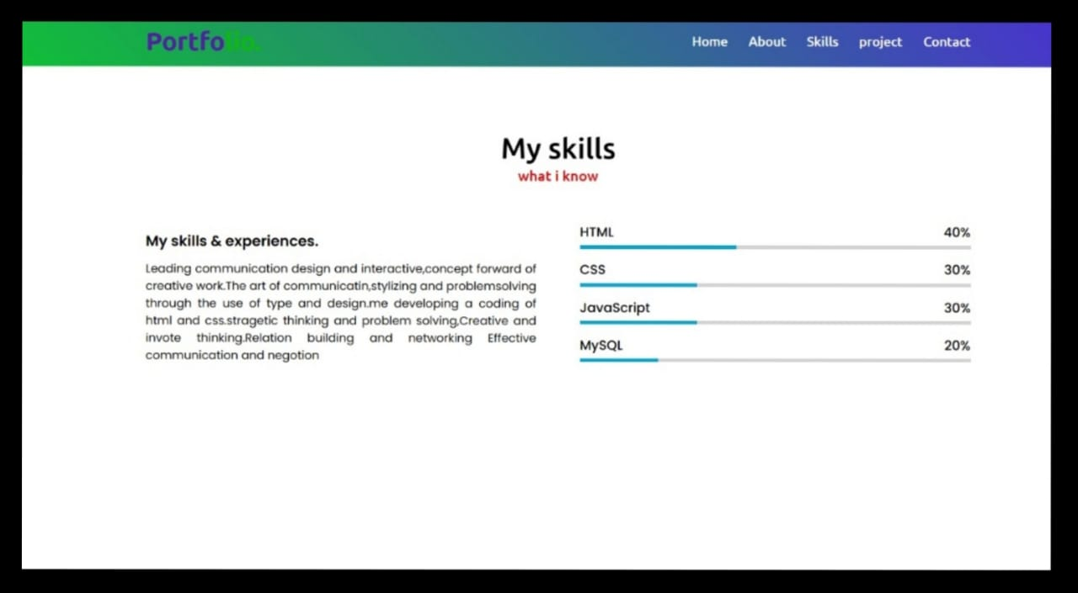

Figure-5.1.1

Discription:

The above figures are skill page, which contain sub

Division named PERSONALSKILLS. Basically, it is an animation,

when the user load the page it will load or fill the

color un the bar from 0th Position.

Source code:

HTML:

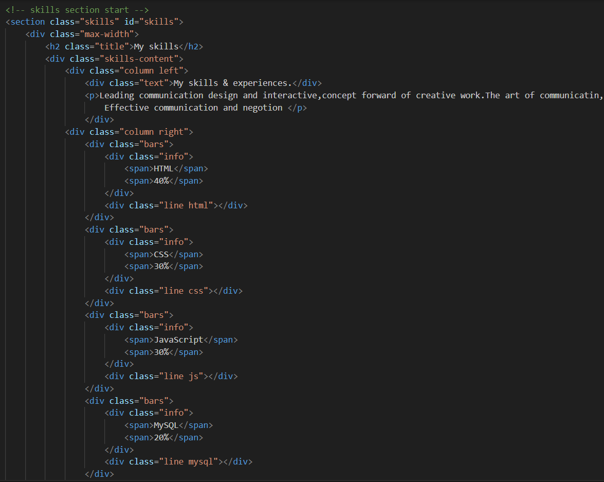

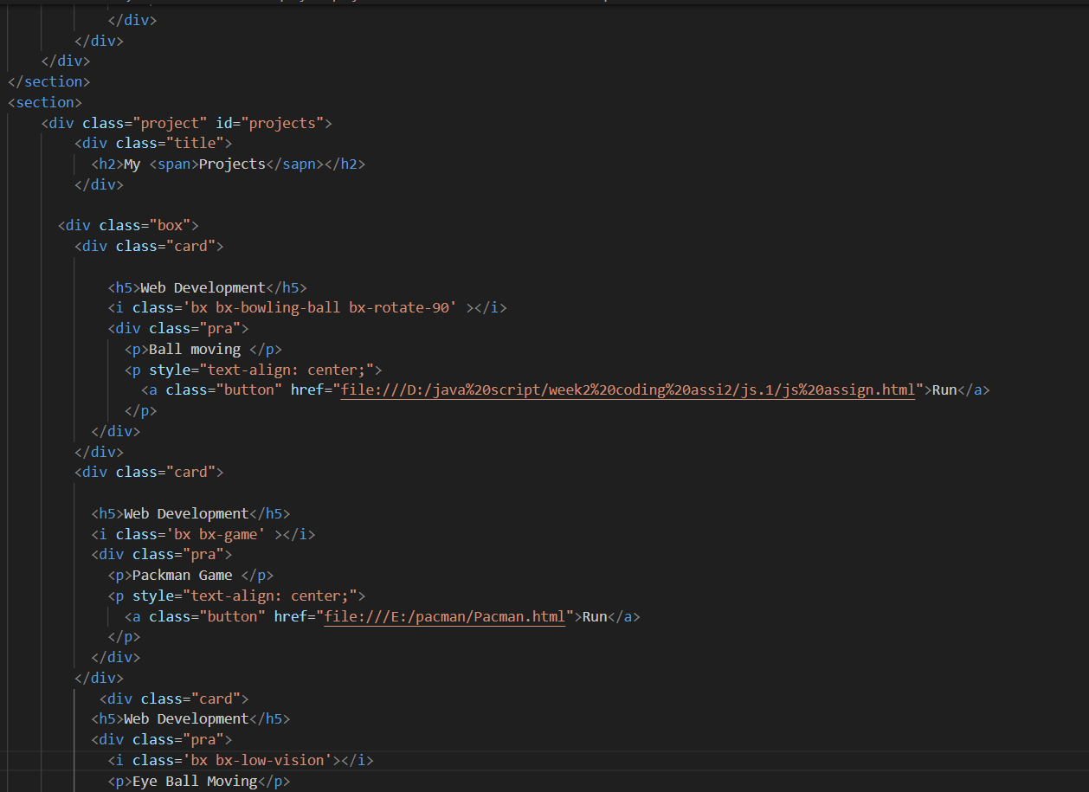

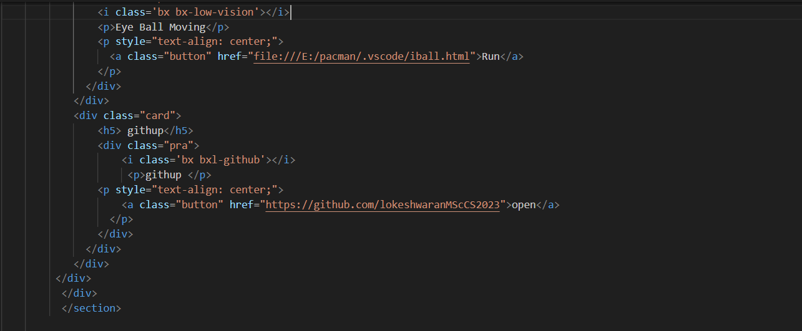

CSS:

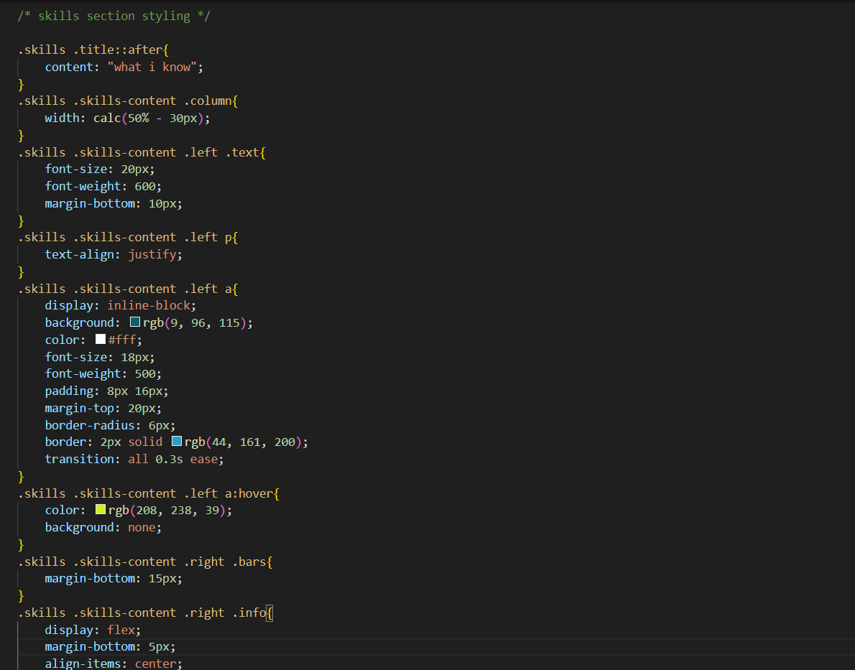

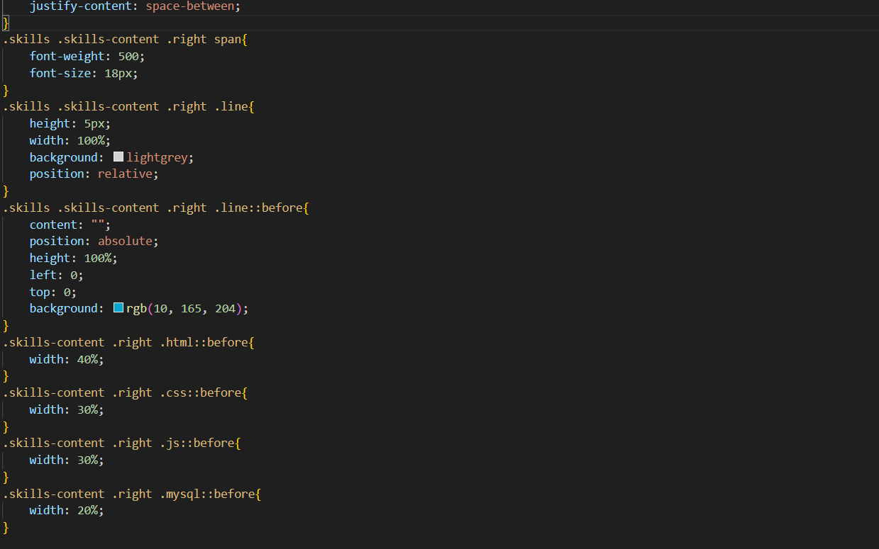

Chapter-6

Style Score

6.1 Font link



6.2 style links

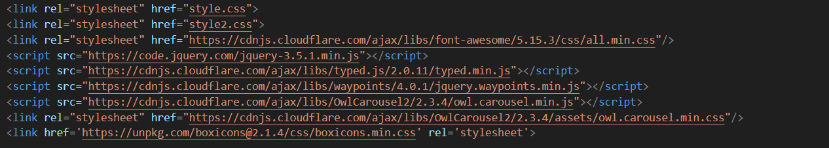

Chapter-7

Website include the following page

7.1 Project page:

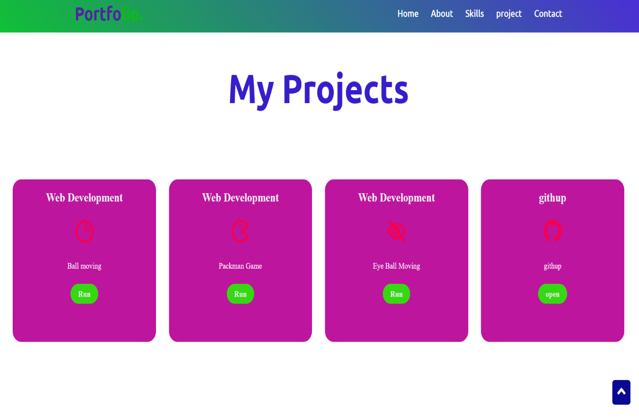

Figure-7.1.1

Discription:

The above figures are worked page, which contain div, heading

And anchor tag for link the code using githup. And also it

Contains gif image describe the tasks

Source code:

HTML

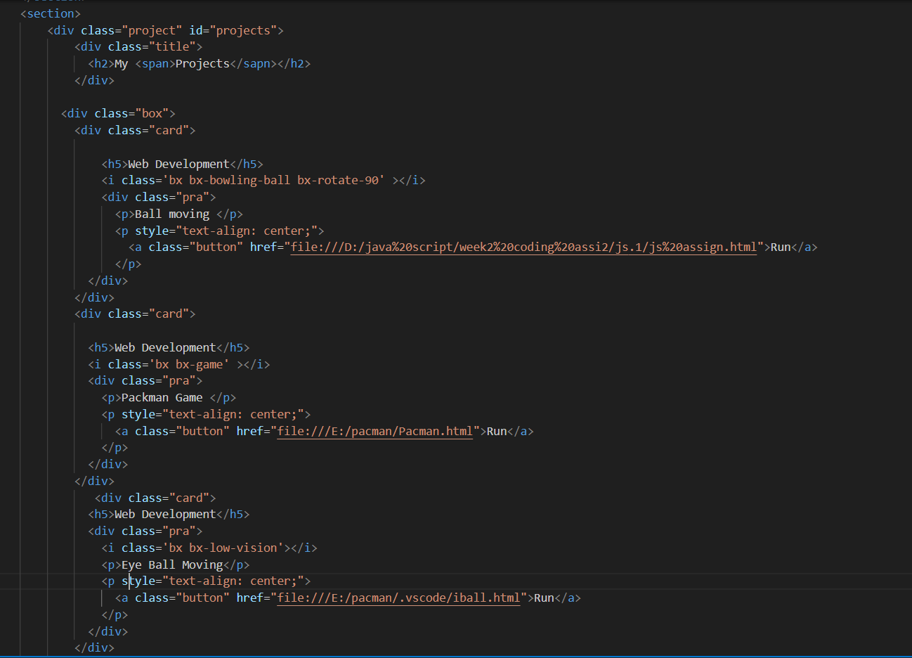

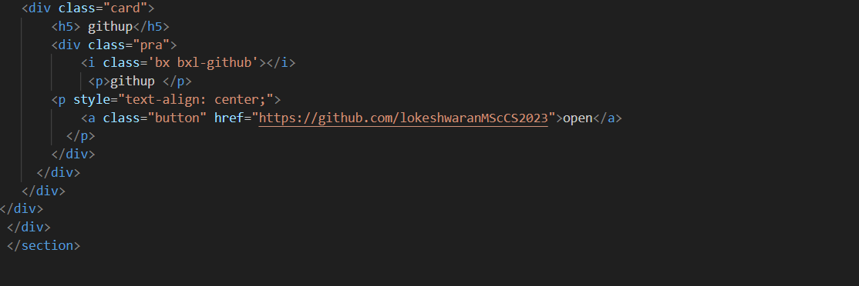

CSS

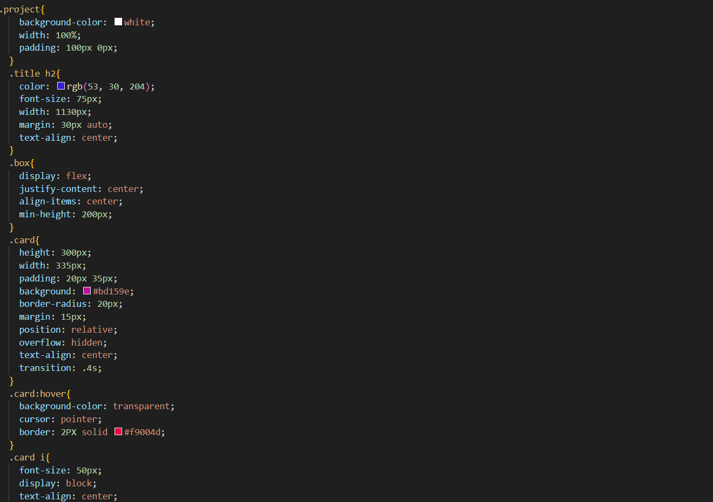

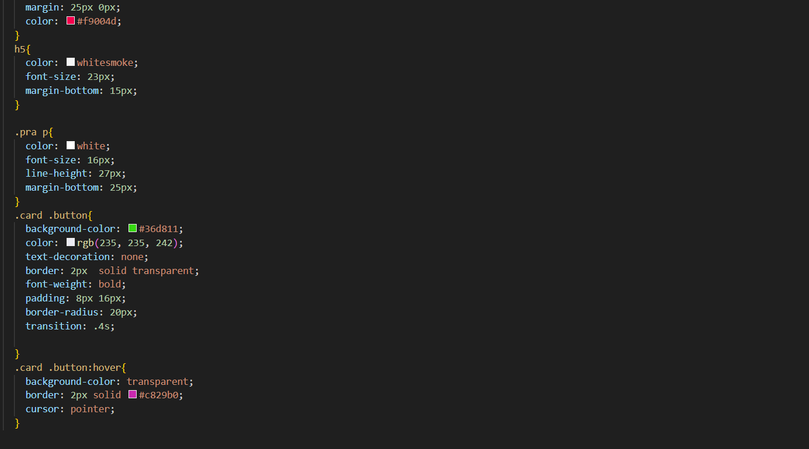

7.2 Project Links to Githup:

### * Project-1

**Title: *SIMULATION BALL MOVEMENT***

**Link:**  https://lokeshwaranmsccs2023.github.io/ball-movement-exercise/

* + - **Project Description:**

This project has a simple green color ball, Which will move from top to bottom and bottom to top, like bouncing from between the x and y axis. It will repeat this process whenever we load the page. The ball is created by HTML, CSS. And making the ball to do some event by JAVASCRIPT.

### Project-2

**Title: *PAC-MAN MOVEMENT***

**Link:**  https://lokeshwaranmsccs2023.github.io/pacman-movement./

* + - **Project Description:**

In Simulation scheduler a Pac-man in made to move is fixed direction and with a fixed velocity. It will move from the one place of the browser to the end of the screen

### Project-3

**Title: *EYE BALL MOVEMENT***

**Link:**  https://lokeshwaranmsccs2023.github.io/Eye-ball-mevement/

**Project Description:**

In this project there will be a two eye, which will move synchronize to follow the directions of the mouse pointer. Mouse events are a popular way to bind the DOM elements to events. So, the eye-ball is selected and make it to move by the use of DOM method. It will move wherever the mouse move in the directions.

# Chapter-8

### 8.1.Project README (Description, steps to run, future improvement)

 **Project-1- Simulation ball movement**

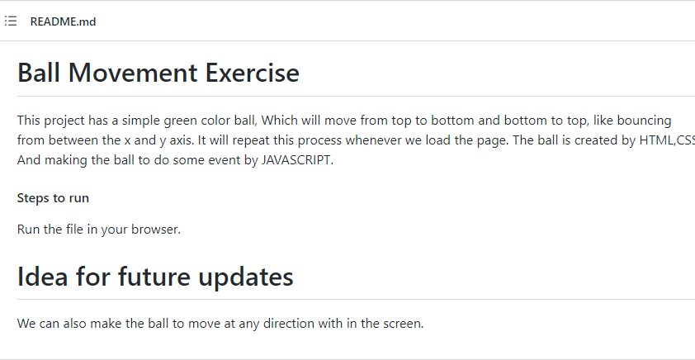

### * Project-2- Pac-Man movement

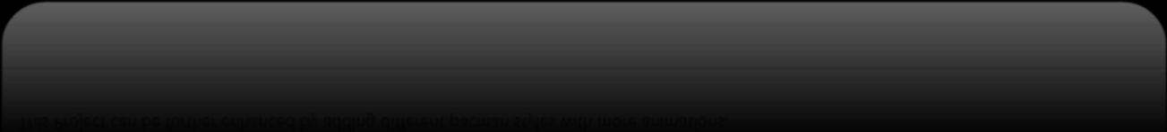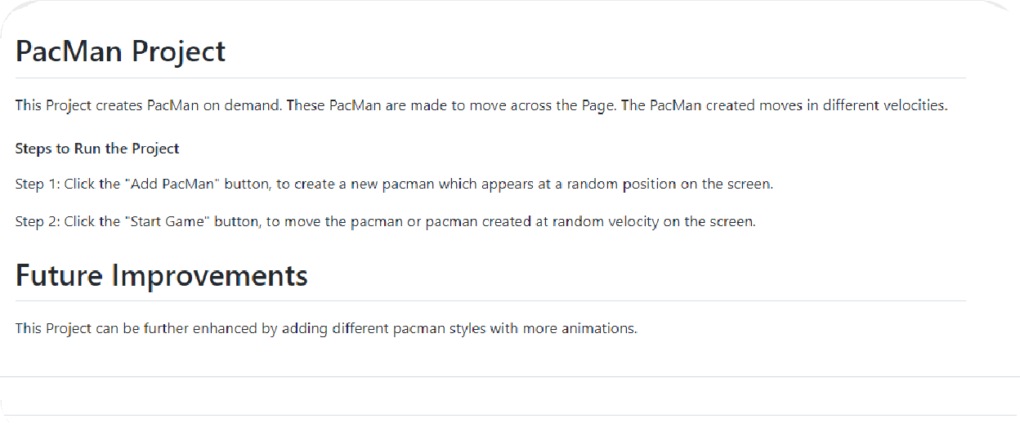

* **Project-3- Eye-ball movement**

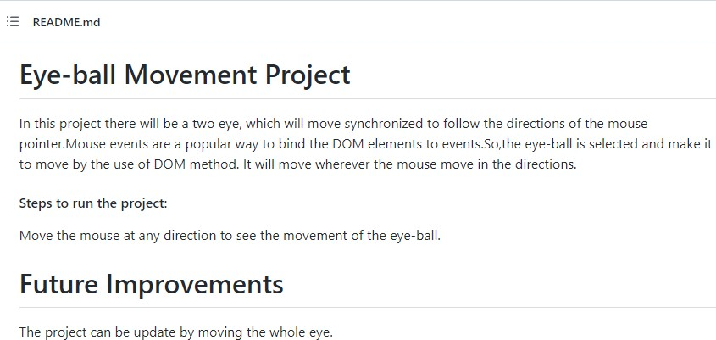

**8.2.Github file structure:**

Task-1 file structure:

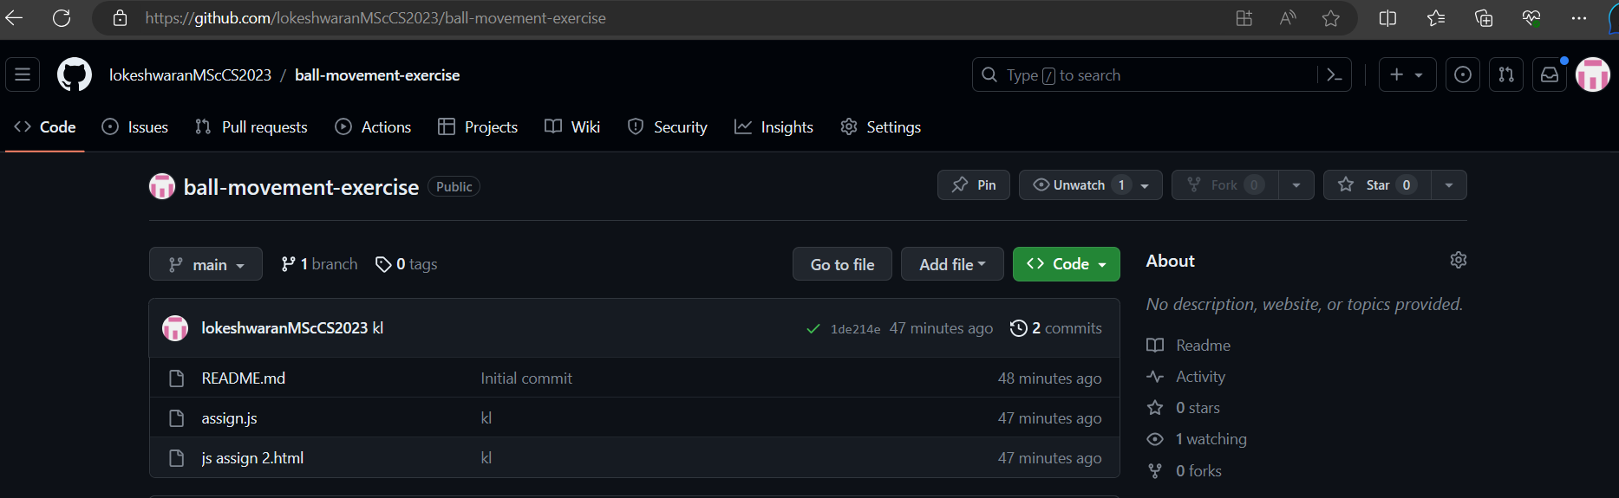

Task-2 file structure:

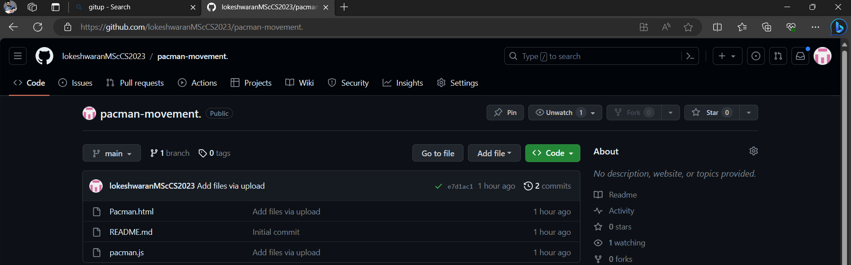

Task-3 file structure:

